**ITS 26000 – Applied Database Tech**

**Lab 11 – (100 points)**

**Use SQL to complete the following exercises.**

### **KimTay Pet Supplies:**

1. Create user, Grant privileges to the user, Revoke privileges, Delete user.
2. Create a new user account. The account name should be a combination of your first initial and your last name. (Ex: flastName)

Create user 'grLee'@'localhost' identified by 'mangotree0867';

1. Allow the new user to select all fields, insert new rows in the CUSTOMER and ITEM tables and delete rows from these tables.

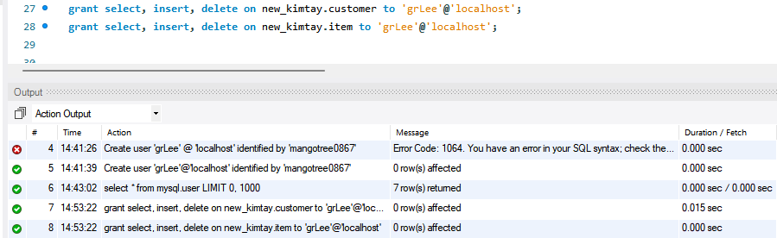

1. Log in to MySQL with the new account. Determine the privileges currently available to the account by corresponding SQL statement. In addition, try to make a query on INVOICE table to see if the new account can do such an operation.

show grants for current_user();

This user does not have privileges for the invoice table

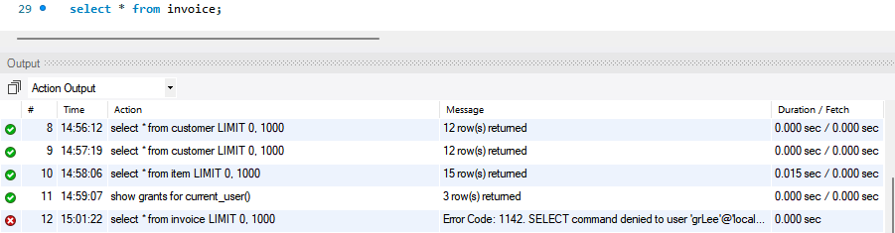

1. Go back to connection with “root” account, revoke all privileges assigned to the new account.

revoke select, insert, delete on new_kimtay.customer from 'grLee'@'localhost';

revoke select, insert, delete on new_kimtay.item from 'grLee'@'localhost';

1. Delete the new account.

drop user 'grLee'@'localhost';



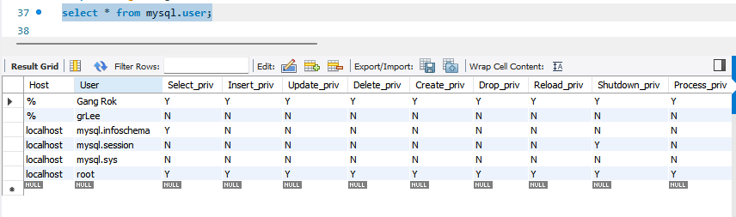

1. Write and execute the commands to do the following with the system catalog:
2. List all the tables contained within the system catalog.

select * from information_schema.tables where table_schema = 'new_kimtay';

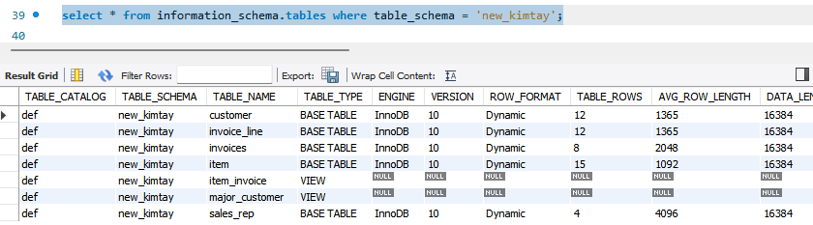

1. List all the columns contained within the system catalog.

select * from information_schema.columns where table_schema = 'new_kimtay';

1. List all the views contained within the system catalog.

select * from information_schema.views where table_schema = 'new_kimtay';

1. Perform the following tasks:
2. Create an index named ITEM_INDEX1 on the ITEM_ID column in the INVOICE_LINE table.

create index item_index1 on invoice_line(item_id);

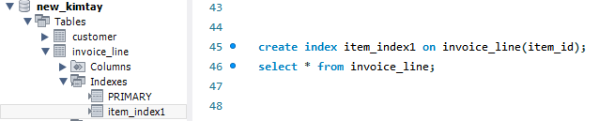

1. Create an index named ITEM_INDEX2 on the CATEGORY column in the ITEM table.

create index item_index2 on item(category);

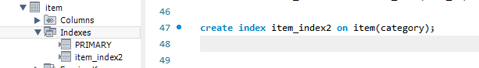

1. Create an index named ITEM_INDEX3 on the CATEGORY and LOCATION columns in the ITEM table.

create index item_index3 on item(category, location);

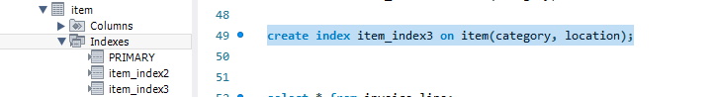

1. Create an index named ITEM_INDEX4 on the CATEGORY and LOCATION columns in the ITEM table. List categories in descending order.

create index item_index4 on item(category desc, location);

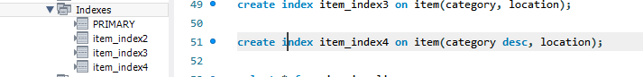

1. Delete the index named ITEM_INDEX3.

drop index item_index3 on item;

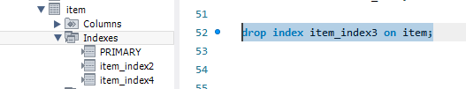

1. Add the INVOICE_NUM column as a foreign key in the INVOICE_LINE table.

ALTER TABLE invoice_line

ADD FOREIGN KEY (invoice_num) REFERENCES invoices(invoice_num);

1. Ensure that the only legal values for the CREDIT_LIMIT column are 250, 500, 750, and 1000.

alter table customer add constraint credit_limit_check check(credit_limit in ('250.00', '500.00', '750.00', '1000.00'));



**Deliverables**: **Document Report with the SQL statement/Query and snapshot of query, its execution and results.** Either word or pdf file need to be uploaded into Brightspace in one submission